2018 Central Oregon Speaker & Workshop Line Up

Main Stage

OPENING CEREMONY AND ACKNOWLEDGEMENTS
11:15 am - Presented by Providence Health Assurance
Speaker -
Duration: 45 mins
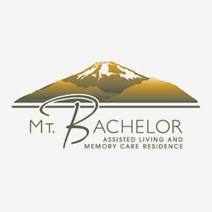

BRINGING ORDER TO CHAOS… RESTORING SANITY
12:00 pm - Mt. Bachelor Assisted Living and Memory Care Presents TAMMIE TO THE RESCUE
Speaker - Tammie Barber
Duration: 45 mins

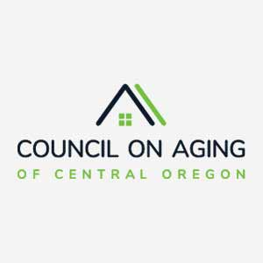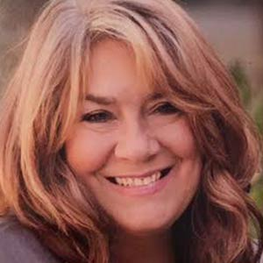

FEATURING KEYNOTE SPEAKER DR. ANABEL PELHAM, Ph.D.

ADVANCING AGE FRIENDLY COMMUNITIES
1:00 pm - Council on Aging of Central Oregon Presents
Speaker - Dr. Anabel Pelham Ph.D. Professor
From - Center for Age Friendly Excellence. (CAFÉ)
What is an age-friendly city? How do you know if your city is working on becoming more age-friendly? Who started the age-friendly cities movement and why is it important for all generations? How can we begin the process in Central Oregon and join the international network? When is the best time to advance our communities and promote policies, programs and services that improve quality of life as we age and enhance respect, understanding and engagement of our diverse older adults? Join the discussion and help lead Central Oregon toward an age-friendly future.
Duration: 45 mins

LIVE MUSIC SESSIONS WITH KEN JOHNSON
2:00 PM - 5:00 PM
Duration: 3 hours

CLASSROOM A

STEM CELL SEMINAR
12:00 pm - Pain Relief Partners Presents
Speaker - Stephanie Jones, RN
Come join pain relief partners and learn more about Wharton’s Jelly Stem Cells, the future of medicine.
Duration: 40 mins

MEDICARE 101
1:00 pm - Providence Health Assurance Presents
Speaker - Don Layton
Description - Medicare is often overwhelming and confusing. You'll find this Boomerama session to be informative and well worth your time. When we're done, you'll have a clear understanding of how Medicare works, what your options are and why Providence may or may not be the right choice for you. Come join us and bring a friend.
Duration: 45 mins

IT’S DIFFERENT “OUT” HERE: PROVIDING DIGNITY AFFIRMING CARE FOR ELDER LESBIANS, GAY, BISEXUAL AND TRANSGENDER OREGONIANS
2:00 pm
Speaker - Melissa Adams MSW, LCSW
Duration: 45 mins

STEM CELL SEMINAR
3:00 pm - Pain Relief Partners Presents
Speaker - Stephanie Jones, RN
Come join pain relief partners and learn more about Wharton’s Jelly Stem Cells, the future of medicine.
Duration: 40 mins

LIVING LOVE IS THE PURPOSE & SOLUTION - INSIDE AND OUT
4:00 pm
Speaker - Matthew McCarthy
Sometimes we resign to the grip of the past and the 'fact' that some relationships are a struggle. Of course, this doesn't feel good. We give up because we don't know the way or we have convinced ourselves we do while struggles continue. Come and explore how nurturing a state of love is the solution to all personal and worldly problems. A transformed life is a light for the world with many returns. You will be empowered with a very simple and reliable takeaway to totally transform your entire life - really. The con-artist inside may express doubt due to past attempts failing, or a belief that things are as good as they can get. I will show you otherwise. The possibilities are worth it - come hang out!.

CLASSROOM B

5 SECRETS TO 100 HEALTHY YEARS
12:00 pm - Plasker Chiropractic & Functional Neurology Presents
Speaker - Dr. Emily Plasker, D.C.
It's never too late for Boomers to start living their ideal 100 Year Lifestyle. In this session, you will develop a vision for an extended life span, learn how to get natural pain relief, avoid prescription drug dependency and get 5 secrets to a highly functional life as you age.
Duration: 45 mins

REVERSE MORTGAGE AS A FINANCIAL TOOL
1:00 pm - Fairway Mortgage Presents
Speaker - Martin Stewart
  - Is reverse mortgage right for you?
  - Myths and Confusion
  - How does it work?
  - Improving retirement income with reverse mortgage.
Duration: 40 mins

NEXT STAGE OF HOUSING
2:00pm - Rogue Real Estate Presents
Speaker - Peggi Schoning
Between 2010 and 2040 it is predicted that the nation’s 65 plus population will grow by roughly 90%. This ballooning number of seniors will impact many industries and especially real estate. There are new challenges and opportunities to explore.
Duration: 30 mins

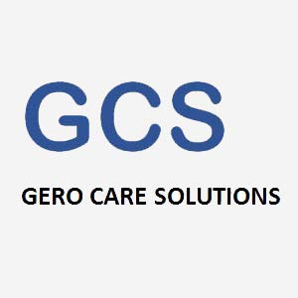

SUBSTANCE ABUSE IN OLDER ADULTS
3:00pm - Gero Care Solutions Presents
Speaker - Tim Malone, LCSW
Receive up-to-date information on the dynamics of substance abuse among the 65+ population. What it looks like, how to tell if someone is using, what are the first steps to take to deal with the problem.
Duration: 45 mins

